Bartlett High Activities Registration

Register online by texting S42228 to 69274 or

Go to PlanetHS.com

(Important GCI users must use website only)

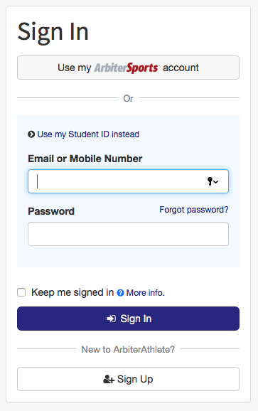

Students must go toPlanetHS.com and create their account first. New users choose **Sign Up**, not Sign In.

Do not use ASD ID for this site. You must use a unique login for arbiter, either phone number or email address. Students and parents must each choose a different login ID.

Parents will also need to create an account, but this should wait until after the student account has been created.

Choose a password you remember and write it down. This will be the same ID and password you will need every time you register for an activity all through high school. If you forget your password, you can click forgot password and it will send a reset to your Email or Mobile number that you used for your Arbiter ID.

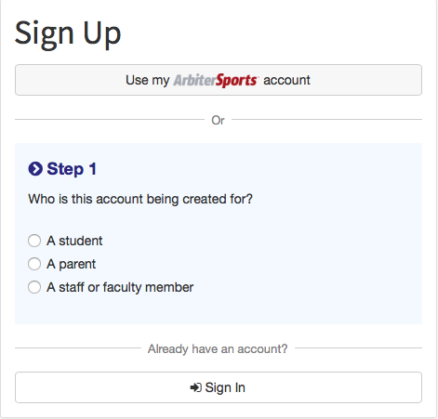

Students need to click on A student and then fill out questions in Step 2 and 3.

Step 4 must say Bartlett High School (Anchorage AK). If you attend a school other than Bartlett, but choose to do activities at Bartlett, you have to choose Bartlett!!

Then click Sign Up.

Bartlett Golden Bears

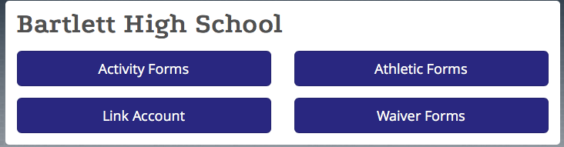

Once in athletic forms, this is where you will link parent account. Click the blue link parent account. Send a message to either their cell number or email address. Remember GCI users need to use email address.

Once you sign up, you will see this. Click on athletic Forms.

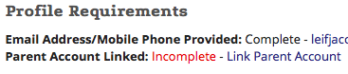

Forms will not be complete until you scroll to the bottom of each one and hit “sign and submit”. Both Students and parents must complete their portion of all forms.

Once all 8 forms have been completed correctly they will say – Complete.

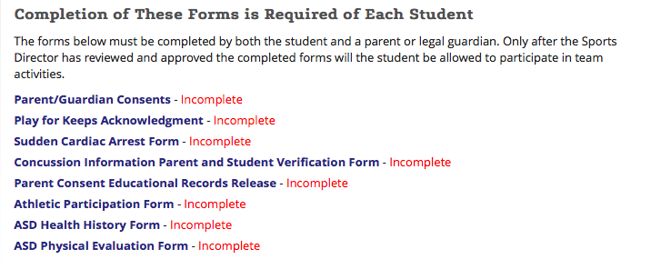

When uploading the Physical, the back side with date must be shown.

**Final Steps:**

Payment can be made online using your parent connect “Q” account. Payment options are listed under Quicklinks. You can also bring cash or check to the activities office.

**Grade Checks:**

All students will need to have a minimum 2.0 GPA at the end of the previous semester to qualify. See the Activities Handbook for further information. Activities will do a grade check as part of the final step.

**IMPORTANT:**

Stop by the Activities office to receive your “Golden Ticket” and grade check. You will not be allowed to attend practice without this final clearance form from Activities.